Group By

Note: Display the party code, not the party description in each of the following
1) Display the number of people in each party. Order by Party. (Make sure to display the party_code)
SELECT partyid, count(partyid) FROM Mendoza_candidate GROUP BY partyid;

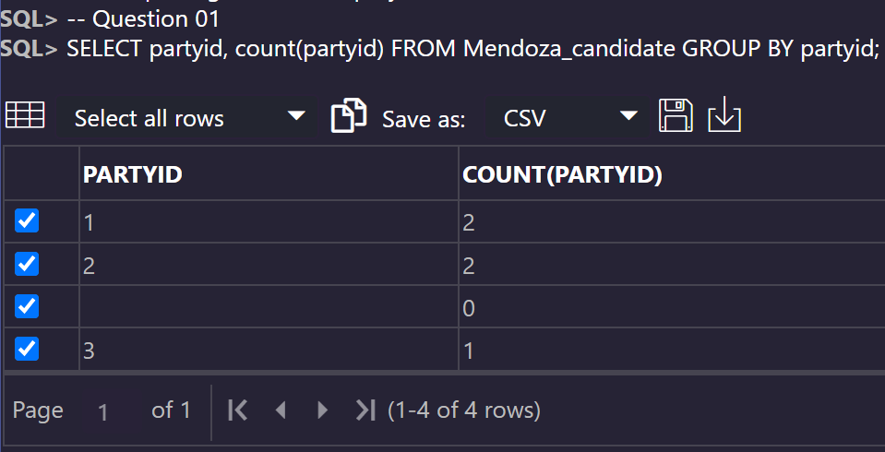
2) Display the number of people in each party whose first name starts with d or r. (Make sure to display the party_code)
SELECT partyid, count(partyid) FROM mendoza_candidate
WHERE lower(fname) LIKE 'd%' OR lower(fname) LIKE 'r%'
GROUP BY partyid;

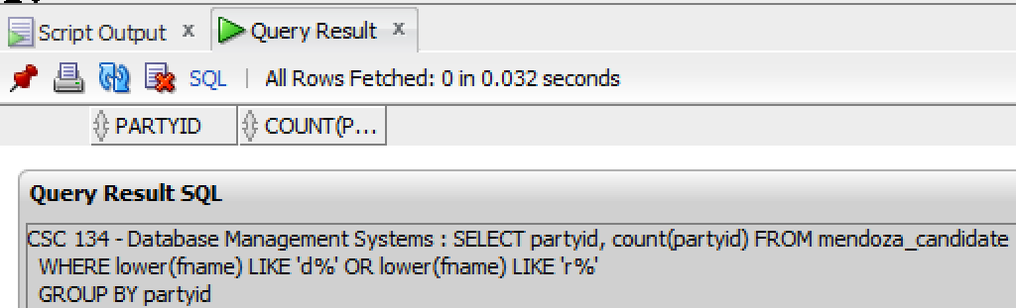

3) Display the average salary for each party (Make sure to display the party_code)
SELECT partyid, avg(salary) FROM Mendoza_candidate GROUP BY partyid;

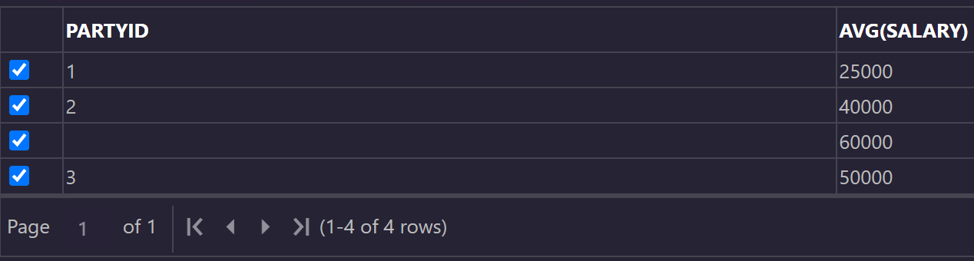
4) Display the number of people in each party where the number of people does not exceed 2
SELECT partyid, COUNT(partyid) FROM mendoza_candidate GROUP BY partyid HAVING COUNT(partyid) >= 2;

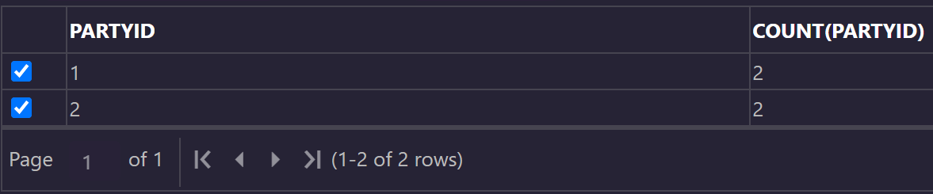
5) Display the average salary for each party where the average does not exceed 50000
SELECT partyid, AVG(salary) FROM mendoza_candidate GROUP BY partyid HAVING AVG(salary) >= 50000;

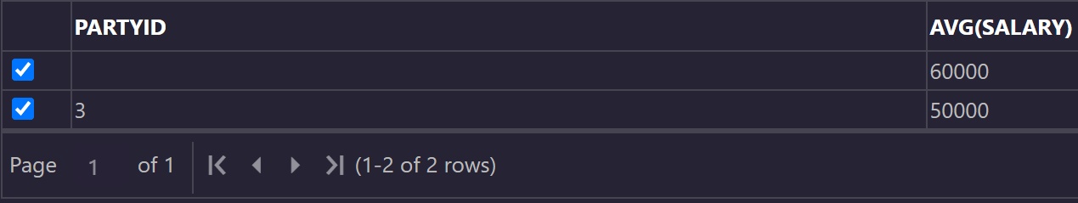
6) Create a new table called candidate2 that contains the number of people in each party. Should contain the partycode and the number of people (CAUTION, you have to use an alias for this to work)
CREATE TABLE mendoza_candidate2 AS SELECT partyid, COUNT(*) party_count FROM mendoza_candidate GROUP BY partyid;

